Scholarship and Leadership Program
Niswonger Foundation Board Update
Thursday, November 17, 2016

Scholar Selection Process
- The interviews for our 2017 Niswonger Scholars were conducted on Thursday, November 10, 2016. We had 91 nominations this year. Nancy interviewed 61 of these nominees to identify the 12 finalists.
- Alumni Matthew Bible, Nick Darnell, Brittany Vogt Jorgenson, and Elizabeth Batson Williams, joined Board Representative Nikki Niswonger as members of this year’s Selection Committee.
- See Board material (Ratification of Scholarship Selections) with names of the Niswonger Scholar candidates for Board discussion and approval.

Leadership Development
- Winter Training will be Monday and Tuesday, December 19-20 at the General Morgan Inn.
- We invite our Board Members to join us for all or part of our training activities.
- Opportunities for informal time with the Scholars will be a casual dinner and holiday party on Monday evening, December 19; and breakfast on Tuesday, December 20, at 8:00 a.m. at the General Morgan Inn.
- Following breakfast on Tuesday, the Scholars will be traveling to Eastman for a meeting with Board Member David Golden. The meeting will begin at 9:45 a.m. in the Corporate Business Center.
- The text for our Winter Training is “Anyway, The Paradoxical Commandments,” by Kent M. Keith. The Scholars have begun “pre-training” assignments that will prepare them for the two days of activities.
- The agenda for 2016 Winter Training is attached to this report.

Scholar Updates
- The calendar for 2016-2017 Scholar activities is included as an attachment.
- Scholar News is included as an attachment.

Alumni Scholar Updates
- Alumni Scholar News is included as an attachment.
- Board Members, with spouses or guests, are invited to join the Alumni Scholars for a Holiday Gathering on Saturday, December 17 at General Morgan Inn.

Niswonger Scholars
WINTER LEADERSHIP TRAINING
December 19-20, 2016

AGENDA

Monday, December 19

10:30 a.m. Freshmen Arrive at the General Morgan Inn and Session Begins in the Board Room (lunch provided for freshmen)

12:30 p.m. – Freshman Session Ends

12:30 – 1:00 p.m. All Other Scholars Arrive and Check In Hotel

1:30 p.m. – General Session Begins

3:30 p.m. – Break

3:45 p.m. – Session Resumes

5:30 p.m. – Break

6:30 p.m. – Dinner and Holiday Fun!

9:00 p.m. –Free Time

Tuesday, December 20

8:00 a.m. – Breakfast at the General Morgan Inn

8:45 a.m. – Depart for Eastman

9:45 a.m. - Session with David Golden, Senior Vice President, Chief Legal Counsel, Sustainability Officer, and Corporate Secretary for Eastman; and Niswonger Foundation Board Member

11:15 a.m. – Break

11:30 a.m. – Scholars Complete Last Session of Training

12:30 p.m. – Winter Training Adjourns (Lunch Provided)

Niswonger Foundation
Current Scholar Planning Calendar

2016

Monday and Tuesday, December 19-20
Winter Training
General Morgan Inn

2017

Summer Training

Monday, May 15 – Thursday, May 18
Van Wert, Ohio Trip

Saturday May 20 - Tuesday, May 23
Sophomore Outdoor Challenge

Thursday, May 25 - Sunday, May 28
Freshmen Bahamas Trip

Sunday, May 28
Freshman Orientation

Tuesday, May 30
Senior Scholars’ Graduation Dinner
7:00 p.m.
General Morgan Inn

Monday, May 29 – Friday, June 2
Scholars’ Summer Training

Saturday, June 3 – Monday, June 12
Senior Trip to Normandy

Tuesday, August 1 – Friday, August 4
Junior Trip to New York City

Winter Training

Thursday and Friday, December 21-22
General Morgan Inn

NISWONGER SCHOLARS SHINE

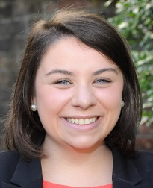
Hope Adkins – (Carson-Newman University, junior) has been elected student representative of the Family and Consumer Science Advisory Board at CN. She has been elected as Chair of C-NAFCS (Carson-Newman Association of Family and Consumer Sciences) Board. She has been elected as vice president of Kappa Omnicron Nu.

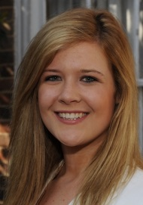
Courtney Johnson - (Maryville College, sophomore) will begin an internship at Blount Memorial Hospital in January. She is forming a Kinesiology Club at Maryville. She has been named USA South Athletic All-Academic Team in Cheerleading.

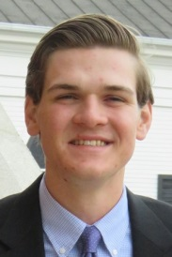
Elijah “Bo” Pless – (Milligan College, freshman) has become a member of LINC (Linking Individuals to the Needs of the Community), Apostolos Missions Club and Society of Scientific Christian Scholars.

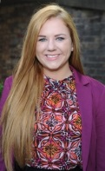
Alora Ricker – (Milligan College, junior) was inducted into Alpha Chi. She has been named Academic All-American in Volleyball.

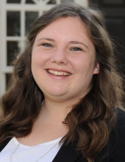
Madeline Standbridge – (University of Tennessee, junior) has been elected as co-director of the Traditions Committee at UT.

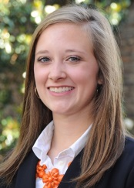
Morgan Thomas – (Clemson University, sophomore) is working as an intern at Hubbard Young Pharmacy in the Compounding Lab. She is an ambassador for the Pre-Professional Health College. She was named to the President’s List at Clemson for her GPA.

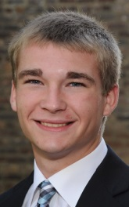
Zachary Ward – (University of Tennessee, sophomore) is working in research in the Bio Chemistry department at UT. He will be synthesizing proteins. He is on the Serving Team for Volunteers for Christ.
ALUMNI SCHOLAR NEWS

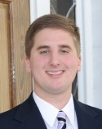
Gage Armstrong – (Class of 2016) is working as a Lab Technician in the Polymers Technology Division at Eastman Chemical.

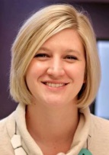
Mary Kate Baker – (Class of 2007) became engaged to William White. They are planning a wedding for May 2017. She was named one of the 2016 Notable Women of East Tennessee State University.

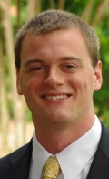
Patrick Brown – (Class of 2009) has been elected to chair the East Tennessee chapter of the American Society of Landscape Architects (ASLA). He is serving as Vice President of the Purdue Club of East Tennessee alumni group.

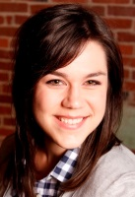
Emily Hollingsworth – (Class of 2011) recently moved to Knoxville and is working as a Production Manager for Pyxl, Inc.

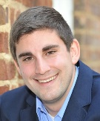
Lawrence Loving – (Class of 2012) is teaching adjunct at East Tennessee State University. He was married to Megan Sanders in April. He completed his Master’s in Business Administration at East Tennessee State University. He accepted a position at the Niswonger Foundation as Coordinator of the CareerConnect Program.

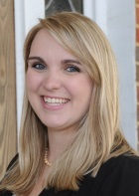
Ivory Shelton – (Class of 2016) has been selected as a student researcher on a project in the Wake Forest University Department of Psychiatry under Dr. Elizabeth Arnold. She was elected as Student Representative to Administration for the Wake Forest School of Medicine Student Government Association.

