Opening session


Dave Weber’s fun, high energy, and entertaining style have made him one of the country’s most sought after speakers. Described as a “Chihuahua on caffeine”, Dave is always a crowd favorite.
As a captivating presenter and phenomenal story teller, Dave has discovered that laughter opens the head and the heart to consider internalizing new principles…and humor is a big part of all of his presentations.
People like to laugh and have fun. Talk to anyone who has just returned from a meeting, conference, or retreat and the first thing they’ll tell you is whether or not it was fun – then they’ll discuss content. Dave’s style might get him invited to present, but it is his great content and timeless principles that get him invited back time and time again.
Dave strongly identifies with the challenges other professionals face. His goal with every presentation is to motivate, challenge, and inspire everyone who hears him...and have a lot of fun along the way. Dave stakes his reputation on change.

In addition to presenting on the motivational speaking circuit, Dave is the author/creator of the LifeTime Organizer and the author of Sticks and Stones: Exposed: The Power of Our Words. He is president and CEO of Weber Associates, Inc., a training and consulting firm in Atlanta, Georgia. He and his wife Tina are the proud parents of two great kids.

Closing session

The closing session will feature a panel discussion on Tennessee’s “First to the Top” Initiative. Each panel member will play a key role in the implementation of this initiative and will discuss their organization’s responsibilities. Ample time will be available for questions from the audience.

Moderator Oliver “Buzz” Thomas President, Knoxville Public
Education Foundation

Panel Members: State Rep. David Hawk Member, Tennessee House
Education Committee
Dr. Tim Webb Tennessee Commissioner of
Education
Dr. Gary Nixon Executive Director, State Board of Education
Brad Smith Executive Director, SCORE
Commission

School Success 2010 will showcase some of the most successful educational accomplishments in East Tennessee. Talented educators will share best practices, learn from each other, and create a network of teachers and administrators with a common vision and common commitment to excellence.

*******************************************************************************************************

Schedule

7:30 – 8:30 REGISTRATION – Niswonger Performing Arts Center
(NPAC) Lobby

8:30 – 8:45 INTRODUCTION – NPAC – Scott Niswonger

8:45 – 10:30 OPENING SESSION – NPAC – Dave Weber

10:45 - 11:45 CONCURRENT SESSIONS – Greeneville High School

11:45 - 12:45 LUNCH – Greeneville High School Cafeteria or Gymnasium
(Provided by the Niswonger Foundation)

12:45 – 1:45 CONCURRENT SESSIONS – Greeneville High School

2:00 – 3:30 CLOSING SESSION – NPAC – A Panel Discussion on
Tennessee’s First to the Top
Initiative

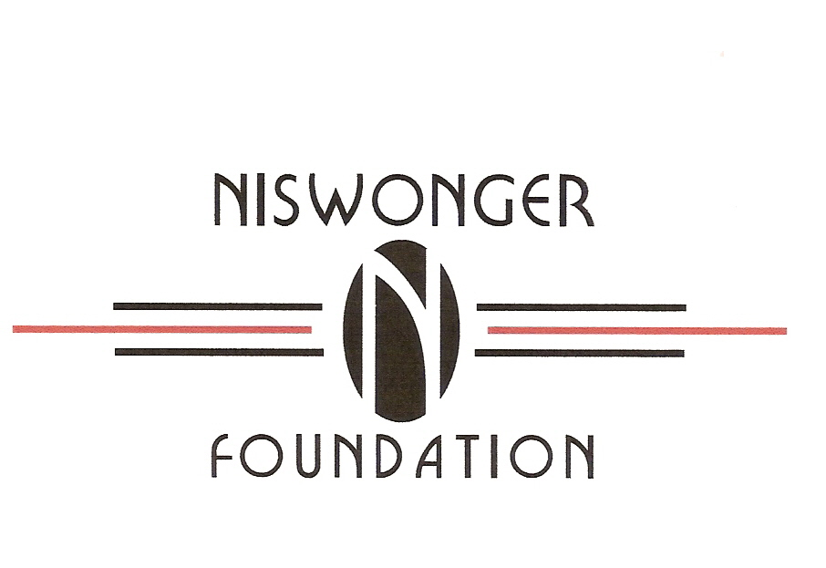

CONCURRENT SESSIONS
10:45 and 12:45

HS-1 Tennessee High School e-Learning Center
Learn how e-learning can enhance the high school curriculum in multiple ways.
Presenters: Dr. Blair Henley, Dr. Gary Lilly – Tennessee High School - Bristol City Schools

HS-2 More Than Just A Freshman Academy
Learn how Greeneville High School Created a Freshman Academy; a mandatory Summer Bridge Program for Grades 8-9; and a mandatory Credit Recovery and Summer School for failing 9th Graders.
Presenters: Dr. Linda Stroud, Johnny Painter – Greeneville High School – Greeneville City Schools

HS-3 Implementing an Expanded AP Program
Explore ways high schools can transition to a more vibrant AP program. Mr. Bays will share how the AP offerings were at expanded Morristown West High School from four to twenty courses.
Presenter: Bradley Bays -- Morristown West High School – Hamblen County

HS-4 Teaching Strategies Video Series
The presenter will share the steps taken to create a professional development video series, designed to focus on best practices in the classroom at Morristown West High School.
Presenter: Tim Landefeld -- Morristown West High School – Hamblen County

HS-5 Preparing Freshmen for High School
Presenters will share strategies used to target middle school high risk students and interventions designed to create a successful high school career for these students.
Presenters: Michelle Simcox, Lisa Arnold, Denise Arnold, and Emogene South – Johnson County Schools

HS-6 Designing and Implementing a High School Career-Guidance Program
The presenter will share multiple strategies for creating and implementing a successful program designed to help middle level and high school students plan their curriculum in a way that enhances their individual career choices.
Presenter: Amy Wagner – North Greene High School – Greene County Schools

HS-7 Implementing “Project Lead The Way”
Learn how PLTW, a strong pre-engineering program, engages students in hands-on, real-world projects. Presenters will focus on the components of PLTW and the process for implementation used at the Center for Technology.
Presenters: Craig Denny, Randy Wells – Greeneville-Greene County Center for Technology

MS-1 Teaching Gifted Children in an Inclusion Classroom
This session will provide ideas, hands on involvement, and competitive activities to meet the needs of a gifted child in the regular classroom.
Presenter: Kim Rominger - Greeneville Middle School - Greeneville City Schools

MS-2 Co-Teaching Strategies
This presentation will focus on strategies used in a co-teaching classroom with inclusion students. Various activities, class structures, and IEP accommodations will be discussed.
Presenters: Christy Trent, Karen Holweg – East Ridge Middle School – Hamblen County

MS-3 Creating a Successful Middle School Alternative Program
Learn how the ACE Academy, designed to meet behavioral and academic goals for middle school students, was created. Presenters will share organizational and teaching strategies based on National and Tennessee Standards for alternative schools.
Presenters: Garry Jett, Mandy Schneitman – ACE Academy -- Jefferson County

MS-4 Success with Standards-Based Assessment
Presenters will share strategies that promote successful implementation of standards- based assessments.
Presenters: Chris Greene, Daniel Lemelin, Eric Helton – West View Middle School – Hamblen County

MS-5 Implementing a Hands-On Science Curriculum for Middle-Level Students
Middle-level science teachers from Hancock County will share the implementation process of a hands-on approach to science instruction for grades 6-8.
Presenters: Michelle Fleenor, JoAnna Nichols -- Hancock Middle School - Hancock County Schools

MS-6 Creating and Maintaining a Positive School Culture
Presenters will provide a brief overview of four crucial elements identified as fundamental in order to facilitate an effective School Wide Positive Behavior Support System.
Presenters: Karen Davis-Beggs, Jacki Wolfe – Rogersville and Surgoinsville Middle Schools – Hawkins County

ES-1 Temple Hill School-Wide Positive Behavior Program
Presenter will discuss “wildcat dollars” used to reward positive behavior and recognize student successes.
Presenter: Larry Howell -- Temple Hill Elementary School – Unicoi County

ES-2 Miracle in the Mountains - The Grassy Fork Elementary School Story
Learn how one of Tennessee’s lowest performing schools became one of its highest.
Focus will be placed on literacy, mathematic strategies, and formative assessments.
Presenters: Dr. Shannon Grooms, Jamie Clark, Angela Self - Grassy Fork Elementary – Cocke County Schools

ES-3 Creating a World-Class Pre-Kindergarten Program
Learn what innovative concepts set this program apart and have earned it statewide recognition.
Presenters: Dr. Karla Kite, Amanda Baker – Grandview Elementary School – Washington County

ES-4 Hancock County Elementary – Interventions that Work
Learn the strategies used by Hancock Elementary School to dramatically increase both value-added and achievement scores.
Presenter: Marta Stapleton - Hancock Elementary School - Hancock County

ES-5 Integrating Technology in the Elementary School Curriculum
Presenters will focus on the use of technology to provide individualized instruction for elementary students. Learn how the use of on-going assessment is a key to this process.
Presenters: Heather Conner, Dawn Webb, Kay Norris - Unicoi Elementary School - Unicoi County Schools

ES-6 Teaching Writing in the Primary Grades
Learn how to manage writing in the classroom, incorporate writing across the curriculum and motivate primary grade students to become independent writers.
Presenter: Channie Phagan – White Pine School – Jefferson County

ES-7 Japan Fulbright Memorial Fund
Hear from a recent participant in the Japan Fulbright Memorial Fund. Learn about the structure and focus of the current Japanese educational system and sources for opportunities that will allow travel to other countries through various programs offered by the International Institute of Education.
Presenters: Sherry Ingram, Donna Coffie -- Rock Creek Elementary School – Unicoi County

ES-8 Bullying Prevention Program
The presenter will share an overview of the Witt Elementary School bullying prevention program.
Presenter: Stan Harville -- Witt Elementary School – Hamblen County

ES-9 Safe Schools/Healthy Students
Presenters will share an overview of the implementation of programs and services incorporated into the Johnson City Schools. Particular attention will be paid to community collaboration and evidence based outcomes.
Presenters: Dr. Janie Snyder, Dr. Greg Wallace – Johnson City Schools

School Success symposium 2010
Registration

Name _____________________________________________________________________________

Home Address ______________________________________________________________________

City ___________________________________________ State _____________ Zip Code _________

Home Phone ___________________ Home email __________________________________________

School System ___________________School _____________________________________________

School/SystemAddress________________________________________________________________

City __________________________________________ State ______________ Zip Code __________

School Phone ___________________ School email ________________________________________

Please indicate job/title

Central Office Administration School Administration Teacher, P-K-5 Teacher, 6-12

Other: _____________________________________________________________________________

Please select two concurrent sessions

Session 1 - 10:45-11:45 ____________________________________________

Session 2 – 12:45-1:45 _____________________________________________

Registration must be returned by: June 1, 2010
No on-site registrations will be accepted

Mail completed form to: Fax completed form to:
Niswonger Foundation Niswonger Foundation
PO Box 5112 Tusculum College (423) 636-0523
Greeneville, TN 37743

Additional programs and registration forms can be down-loaded at:
www. niswongerfoundation.org

